Name of Student : Raghav Mahesh Sarda PRN: 25070122235
Subject: Programming with Java Semester: III
ASSIGNMENT No : 15 Year: AY 2026-27
TITLE : Exception Handling using Finally, Throw, and Throws

Problem Statement
Write a Java program to demonstrate exception handling using finally, throw, and throws.

Learning Objectives
To implement finally, throw, and throws for effective exception management.

Program:
ThrowFinally.java
// Assignment 15 - Exercise 1: Using throws keyword and finally block
import java.util.*;
public class ThrowFinally
{
public static int divide(int a, int b) throws ArithmeticException // Method declaring exception using throws
{
return (a / b); // Division that can throw ArithmeticException
}

public static void main(String args[]) // Main Method
{
Scanner sc = new Scanner(System.in);
System.out.print("Enter Numerator: ");
int num = sc.nextInt();
System.out.print("Enter Denominator: ");
int den = sc.nextInt();

try
{
int ans = divide(num, den); // Calling method that throws exception
System.out.println("Division Result = " + ans);
}
catch(ArithmeticException e) // Catching arithmetic error
{
System.out.println("Exception: Cannot divide by zero!"); // Handling exception
}
finally // Always executes
{
System.out.println("Finally block executed."); // Always executed
sc.close();
}
}
}

ThrowProgram.java
// Assignment 15 - Exercise 2: Using throw keyword for user validation
import java.util.*;
public class ThrowProgram
{
public static void validateAge(int age) // Validation method
{
if(age < 18) // Eligibility check
{
throw new ArithmeticException("Age is under 18: Not Eligible"); // Explicitly throwing exception
}
else // Valid age condition
{
System.out.println("Eligible"); // Success message
}
}

public static void main(String args[]) // Main Method
{
Scanner sc = new Scanner(System.in);
System.out.print("Enter Your Age: ");
int userAge = sc.nextInt();
try
{
validateAge(userAge); // Calling validation method
}
catch(ArithmeticException e) // Catching explicitly thrown exception
{
System.out.println("Exception: " + e.getMessage());
}
finally
{
System.out.println("Verification process complete."); // Final status
sc.close();
}
}
}

Output:
ThrowFinally.java
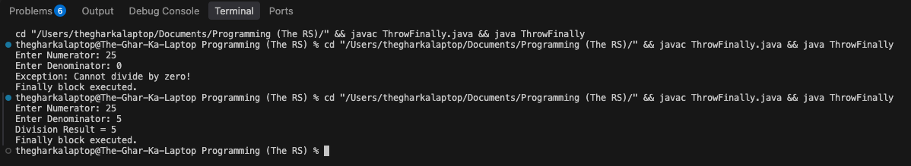

ThrowProgram.java
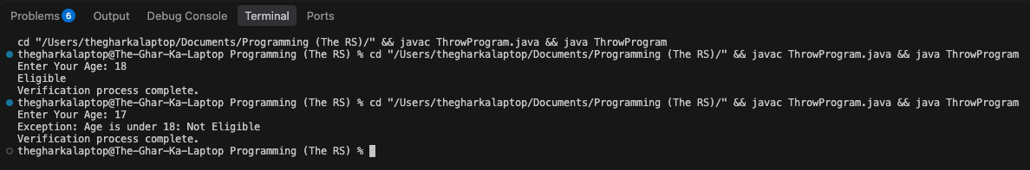

Conclusion:
In this assignment, the advanced exception handling keywords finally, throw, and throws were successfully implemented and verified. The throws clause passed potential exceptions to the calling method, the throw keyword manually triggered custom exceptions as per constraints, and the finally block ensured cleanup and termination statements executed consistently regardless of runtime failures.

